- To write a Java Program to design an interface for Stack ADT and implement Stack ADT using both Array and Linked List.

import java.io.*;
interface Mystack
{
public void pop();
public void push();
public void display();
}
class Stack_array implements Mystack
{
final static int n=5;
int stack[]=new int[n];
int top=-1;
public void push()
{
try
{
BufferedReader br=new BufferedReader(new InputStreamReader(System.in));
if(top==(n-1))
{
System.out.println(" Stack Overflow");
return;
}
else
{
System.out.println("Enter the element");
int ele=Integer.parseInt(br.readLine());
stack[++top]=ele;
}
}
catch(IOException e)
{
System.out.println("e");
}
}
public void pop()
{
if(top<0)
{
System.out.println("Stack underflow");
return;
}
else
{
int popper=stack[top];
top--;
System.out.println("Popped element:" +popper);
}
}

public void display()
{
if(top<0)
{
System.out.println("Stack is empty");
return;
}
else
{
String str=" ";
for(int i=0; i<=top; i++)
str=str+" "+stack[i]+" <--";
System.out.println("Elements are:"+str);
}
}
}
class Link
{
public int data;
public Link nextLink;
public Link(int d)
{
data= d;
nextLink=null;
}
public void printLink()
{
System.out.print(" --> "+data);
}
}
class Stack_List implements Mystack
{
private Link first;
public Stack_List()
{
first = null;
}
public boolean isEmpty()
{
return first == null;
}
public void push()
{
try
{
BufferedReader br=new BufferedReader(new InputStreamReader(System.in));
System.out.println("Enter the element");
int ele=Integer.parseInt(br.readLine());
Link link = new Link(ele);
link.nextLink = first;
first = link;
}
catch(IOException e)
{
System.err.println(e);
}
}
public Link delete()
{
Link temp = first;
try
{
first = first.nextLink;
}
catch(NullPointerException e)
{
throw e;
}
return temp;
}
public void pop()
{
try
{
Link deletedLink = delete();
System.out.println("Popped: "+deletedLink.data);
}
catch(NullPointerException e)
{
throw e;
}
}
public void display()
{
if(first==null)
System.out.println("Stack is empty");
else
{
Link currentLink = first;
System.out.print("Elements are: ");
while(currentLink != null)
{
currentLink.printLink();
currentLink = currentLink.nextLink;
}
System.out.println("");
}
}
}
class StackADT
{
public static void main(String arg[])throws IOException
{
BufferedReader br=new BufferedReader(new InputStreamReader(System.in));
System.out.println("Implementation of Stack using Array");
Stack_array stk=new Stack_array();
int ch=0;
do
{
System.out.println("1.Push 2.Pop 3.Display 4.Exit 5.Use Linked List");
System.out.println("Enter your choice:");
ch=Integer.parseInt(br.readLine());
switch(ch)
{
case 1:
stk.push();
break;
case 2:
stk.pop();
break;
case 3:
stk.display();
break;
case 4:
System.exit(0);
}
}
while(ch<5);
System.out.println("Implementation of Stack using Linked List");
Stack_List stk1=new Stack_List();
ch=0;
do
{
System.out.println("1.Push 2.Pop 3.Display 4.Exit");
System.out.println("Enter your choice:");
ch=Integer.parseInt(br.readLine());
switch(ch)
{
case 1:
stk1.push();
break;
case 2:
try
{
stk1.pop();
}
catch(NullPointerException e)
{
System.out.println("Stack underflown");
}
break;
case 3:
stk1.display();
break;
default:
System.exit(0);

}
}
while(ch<5);
}
}

OUTPUT:
Implementation of Stack using Array
1.Push 2.Pop 3.Display 4.Exit 5.Use Linked List
Enter your choice:
1
Enter the element
10
1.Push 2.Pop 3.Display 4.Exit 5.Use Linked List
Enter your choice:
1
Enter the element
15
1.Push 2.Pop 3.Display 4.Exit 5.Use Linked List
Enter your choice:
1
Enter the element
25
1.Push 2.Pop 3.Display 4.Exit 5.Use Linked List
Enter your choice:
3
Elements are: 10 <-- 15 <-- 25 <--
1.Push 2.Pop 3.Display 4.Exit 5.Use Linked List
Enter your choice:
5
Implementation of Stack using Linked List
1.Push 2.Pop 3.Display 4.Exit
Enter your choice:
1
Enter the element
10
1.Push 2.Pop 3.Display 4.Exit
Enter your choice:
1
Enter the element
15
1.Push 2.Pop 3.Display 4.Exit
Enter your choice:
1
Enter the element
20
1.Push 2.Pop 3.Display 4.Exit
Enter your choice:
3
Elements are: --> 20 --> 15 --> 10
1.Push 2.Pop 3.Display 4.Exit
Enter your choice:
2
Popped: 20
1.Push 2.Pop 3.Display 4.Exit
Enter your choice:
3
Elements are: --> 15 --> 10
1.Push 2.Pop 3.Display 4.Exit
Enter your choice:
4
2 Write a Java program that loads names and phone numbers from a text file where the data is organized as one line per record and each field in a record are separated by a tab (\t). It takes a name or phone number as input and prints the corresponding other value from the hash table (hint: use hash tables).

import java.io.*;
import java.util.*;
public class Phonebook
{
public static void main(String args[])
{
try
{
FileInputStream fis=new FileInputStream("//home/gcet/Desktop/myfile.txt");
Scanner sc=new Scanner(fis).useDelimiter("\t");
Hashtable<String,String> ht=new Hashtable<String,String> ();
String[] strarray;
String a,str;
while(sc.hasNext())
{
a=sc.nextLine();
strarray=a.split("\t");
ht.put(strarray[0],strarray[1]);
System.out.println("hash table values are "+strarray[0]+":"+strarray[1]);
}
Scanner s=new Scanner(System.in);
System.out.println("Enter the name as given in the phone book");
str=s.next();
if(ht.containsKey(str))
{
System.out.println("phone no is"+ht.get(str));
}
else
{
System.out.println("Name is not matched");
}
}
catch(Exception e)
{
System.out.println(e);
}
}
}

Myfile.txt
Surya 567
Ravi 456
Sudha 678

Output:
Surya: 567
Ravi: 456
Sudha: 678
Enter the name as given in the phone book
Ravi
phone no is: 456
Enter the name as given in the phone book
Soni
Name is not matched

3. Write a Java program that connects to a database using JDBC and does add, delete, modify and retrieve operations.

import java.io.BufferedReader;
import java.io.IOException;
import java.io.InputStreamReader;
import java.sql.*;

public class EmployeeDB {
private Connection con=null;
private Statement st=null;
private ResultSet rs=null;
private PreparedStatement pst=null;
EmployeeDB() throws ClassNotFoundException, SQLException ,IOException
{
Class.forName("oracle.jdbc.driver.OracleDriver");
con=DriverManager.getConnection("jdbc:oracle:thin:@localhost:1521:XE","HR","HR");

InputStreamReader isr = new InputStreamReader(System.in);
BufferedReader br =new BufferedReader(isr);
System.out.println("MENU\n1.CREATE\n2.INSERT\n3.UPDATE\n4.DELETE\n");
for(;;)
{
System.out.println("Enter your choice\n");
int ch=Integer.parseInt(br.readLine());
switch(ch)
{
case 1:
System.out.println("Enter your query to create a table\n");
String q1=br.readLine();
st=con.createStatement();
st.execute(q1);
System.out.println("Query executed successfully");
break;
case 2:
System.out.println("Enter your query to Update the table\n");
String q2=br.readLine();
pst=con.prepareStatement(q2);
pst.executeUpdate(q2);
System.out.println("Query executed successfully");
break;
case 3:
System.out.println("Enter your query for selection");
String q3=br.readLine();
st=con.createStatement();
rs=st.executeQuery(q3);
DisplayRS(rs);
System.out.println("Query executed successfully");
break;
case 4:
System.out.println("Enter your query to delete from table\n");
String q4=br.readLine();
st=con.createStatement();
st.executeUpdate(q4);
System.out.println("Query executed successfully");
break;
default:
System.exit(0);

}

}
}
public static void main(String[] args) throws ClassNotFoundException, SQLException, IOException
{
final EmployeeDB s1=new EmployeeDB();
System.out.println("MENU\n1.INSERT\n2.UPDATE\n3.DELETE");
}

private void DisplayRS(ResultSet rs) throws SQLException {
ResultSet rs1=rs;
ResultSetMetaData rsm=rs1.getMetaData();
int col=rsm.getColumnCount();
int count=1;
boolean b=rs1.next();
if(!b)
{
System.out.println("Data not found");
}
else
do
{ System.out.println("Record" +(count++)+"=>");
for(int j=0;j<col;j++)
System.out.println(rs1.getString(j+1)+"\t");
System.out.println ("");
} while(rs1.next()); } }

4. Write a java program that prints the meta-data of a given table

ConnectionUtil.Java
package LabProgs;
import java.sql.Connection;
import java.sql.DriverManager;
import java.sql.SQLException;
public class ConnectionUtil
{
public static Connection getConnection() throws SQLException {
Connection connection = null;
try {
Class.forName("com.mysql.jdbc.Connection");
connection = DriverManager.getConnection("jdbc:mysql://127.0.0.1:3306/test",
"root", "system");
} catch (ClassNotFoundException e) {
e.printStackTrace();
} catch (SQLException e) {
e.printStackTrace();
}
return connection;
}

import java.io.*;
import java.sql.*;
import java.util.*;
import java.util.logging.Level;
import java.util.logging.Logger;
public class Prog14 {
public static void main(String args[]) {
try {
Connection conn = null;
conn = ConnectionUtil.getConnection();
Prog14 prog14 = new Prog14();
prog14.printMetaData(conn, "student_details");
} catch (SQLException ex) {
Logger.getLogger(Prog14.class.getName()).log(Level.SEVERE, null, ex);
}
}
private void printMetaData(Connection conn, String tableName) {
String query = "select * from " + tableName;
Statement statement;
try {
statement = conn.createStatement();
ResultSetMetaDatametaData = statement.executeQuery(query).getMetaData();
longcolSize = metaData.getColumnCount();
System.out.println("There are "+ colSize + " columns in table
"+tableName);
System.out.println("Columns are:");
for(inti=1;i<=colSize;i++) {
String colName = metaData.getColumnLabel(i);
String colType = metaData.getColumnTypeName(i);
System.out.println(colName+"-->"+colType);
}
} catch (SQLException e) {
e.printStackTrace();

}
}
}

5. Write a java program to implement client-server application
import java.net.*;
import java.io.*;
import java.util.*;
public class TcpClient
{
public static void main(String args[])throws IOException
{
try
{
//creating client socket with default ip and port nos and establishing connection with server whose ip is 127.0.0.0 and port 95
Socket con= new Socket("localhost",95);
//creating in object to read data from socket
BufferedReader in=new BufferedReader(new InputStreamReader(con.getInputStream()));
//creating out object to write data into socket
PrintWriter out=new PrintWriter(con.getOutputStream(),true);
while(true)
{
System.out.print("enter the message to the server:");
BufferedReader din=new BufferedReader(new InputStreamReader(System.in));
//reading data from keyboard inorder to send to server
System.out.println("Enter 5 nums");
int a[]=new int[5];
for(int i=0;i<5;i++){
a[i]=Integer.parseInt(din.readLine());
}
String st=Arrays.toString(a);
//writing(sending) data to server
out.println(st);
//reading(recieving) data from server
String s1=in.readLine();
//printing data recived from server on console
System.out.println("from server:"+s1);
if(st.equalsIgnoreCase("bye")||st==null)
break;
}
//closing all the streams opened
in.close();
out.close();
con.close();
}
catch(UnknownHostException e)
{
}

}
}
import java.net.*;
import java.io.*;
import java.util.*;
public class TcpServer
{
public static void main(String args[])throws IOException
{
try
{
//Server scoket creation with default ip address and port no 95
ServerSocket s= new ServerSocket(95);
System.out.println("Server Waiting for the Client");
//waiting for client requests
Socket cs=s.accept();
//Fetching client address and displaying
InetAddress ie=cs.getInetAddress();
String cli=ie.getHostAddress();
System.out.println("Connected to the client with IP "+cli);
//creating in object on client socket for read
BufferedReader in=new BufferedReader(new InputStreamReader(cs.getInputStream()));
//creating out object on clinet socket for write
PrintWriter out=new PrintWriter(cs.getOutputStream(),true);
do
{
//reading(recieving) data from client(if no data from client waits till data is ready)
String st=in.readLine();
//converting into array
String c[]=st.replaceAll("\\[","").replaceAll("]","").replaceAll(" ","").split(",");

int n[]=new int[c.length];
for(int i=0;i<c.length;i++){
n[i]=Integer.valueOf(c[i]);
}
//sorting
TcpServer ts=new TcpServer();
ts.sort(n);
String res=Arrays.toString(n);
//writing(sending) data to client
out.println(res);
if(st.equalsIgnoreCase("bye")||st==null)
break;
//printing data from client on console
System.out.println("from client. "+st);
}while(true);
//closing all streams opened
in.close();
out.close();
cs.close();
}
catch(IOException e)
{
}

}

void sort(int n[]){
int i,j,temp;
int l=n.length;
for(i=0;i<l-1;i++){
for(j=0;j<l-i-1;j++){
if(n[j]>n[j+1]){
temp=n[j];
n[j]=n[j+1];
n[j+1]=temp;
}
}
}
}

}

6. Write a program to prompt the user for a hostname then looks up the IP address for the hostname and read the webpage name then display the contents of the webpage.

import java.io.*;
import java.net.*;
import java.util.*;
public class IpTest
{
public static void main(String arg[])throws UnknownHostException,MalformedURLException,IOException
{
InetAddress addr=InetAddress.getLocalHost();
String Ipad=addr.getHostAddress();
String HostName=addr.getHostName();
System.out.println("IP address is"+Ipad);
System.out.println("HostName is"+HostName);
Scanner sc=new Scanner(System.in);
System.out.println("Enter a website(eg:https://www.google.com)");
String address=sc.next();
URL url = new URL(address);
BufferedReader in = new BufferedReader(new InputStreamReader(url.openStream()));
BufferedWriter writer = new BufferedWriter (new FileWriter("data.html"));
String inputLine;
while ((inputLine = in.readLine()) != null) {
// Process each line.
System.out.println(inputLine);
writer.write(inputLine);
writer.newLine();
}
in.close();
writer.close();

}
}

- Develop and demonstrate a HTML5 document that illustrates the use of ordered list, unordered list, table, borders, padding, color, and the <div> & <span> tag.
//css file :1.css
body { background-color:pink; }
table { border: 2px solid; padding: 0px; }
th {background-color:green; border: 1px solid black; padding:8px; } td { border: 1px solid black; padding:8px; }
ol { font-size:80%; list-style:lower-roman; }
span { background-color:yellow; font-size:120%; font-style:italic; } p { font-size:90%; }

program.html:

<html>
<head>
<link rel="stylesheet" type="text/css" href="1.css" />
<title> lab program 7</title>
</head>
<body>
<h1> this header is 36 pt </h1>
<h2> this header is blue </h2>
<p> this paragraph has a left margin of 50 pixels </p>
<table>
<tr>
<th> name </th>
<th> email </th>
<th> ph num </th>
</tr>
<tr>
<td> Xyz </td>
<td> xyz@gmail.com </td>
<td> 12345 </td>
</tr>
<tr>
<td> Raju </td>
<td> raju@vvit.net </td>
<td> 987654 </td>
</tr>
<tr>
<td> AJP</td>
<td> ajp@yahoo.com</td>
<td> 78563 </td>
</tr>
<ol>
</table>
<hr />
<ol>

<li>ISE </li>
<li>CSE </li>
<li>ECE </li>
</ol>
<p>
<span>this is a text.</span> this is a text.this is a text.this is a text.this is a text. this is a text.this is a text.this is a text.this is a text. <span>this is a text.</span>
</p>
</body>
</html>

Output:
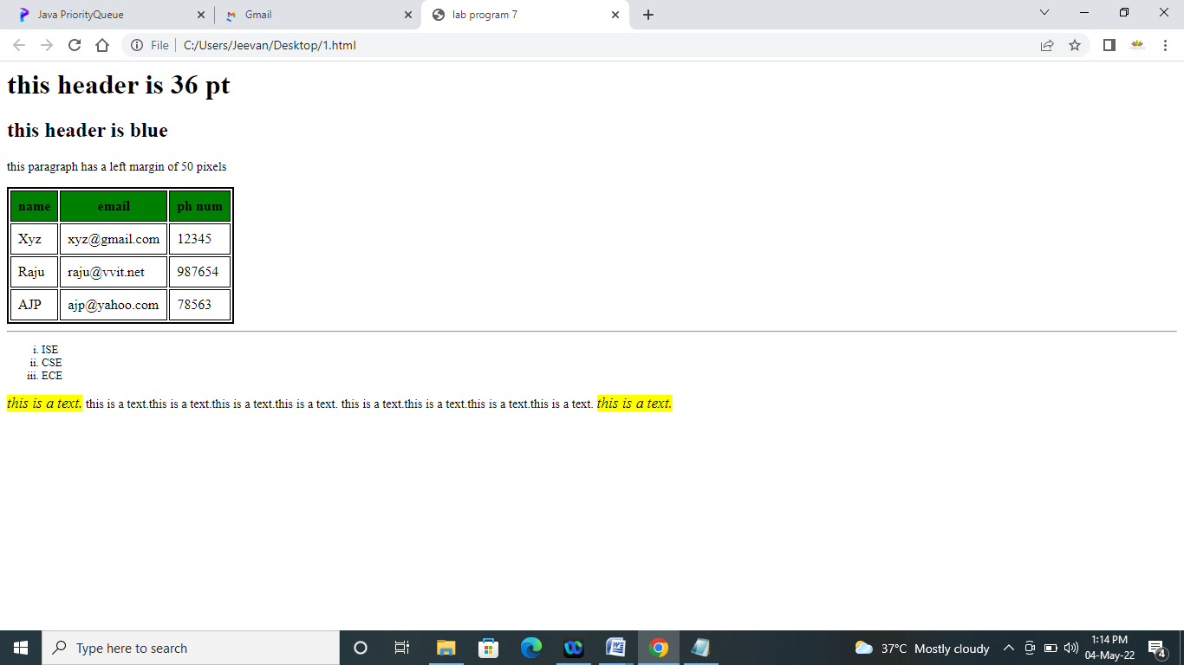

- To create a webpage with the following using HTML
a.To embed an image in web page
b.To fix the hot spots.
c.Show all the related information when a hot spot is clicked in the map

- Create a web page with all types of Cascading style sheets(10th program from lab cycle)

Ext.css
body {
background-color: powderblue;
}
h1 {
color: blue;
}
p {
color:pink;
}

Ext.html

<!DOCTYPE html>
<html>
<head>
<link rel="stylesheet" href="styles.css">
<style>
body {background-color: powderblue;}
h2 {color: magenta;}
h3 {color: red;}
</style>
</head>
<body>
<h1>This is a External CSS</h1>
<p>This is External CSS</p>
<h2>This is Internal CSS</h2>
<h3>This is Internal CSS</h3>
<h4 style="color:black;font-family: verdana;font-size: 300%;">
This is Internal CSS</h4>
</body>
</html>
OUTPUT:
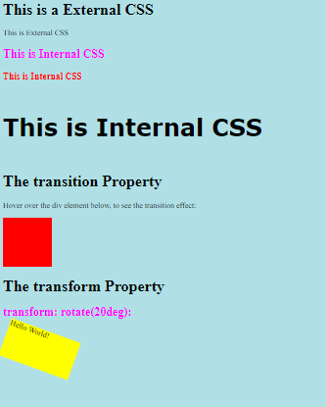

- Create a web page with the following using CSS☹lab experiment 11)
  - Text shadows, rounded corners and box shadows.
  - Linear and Radial gradients.
  - Animation
  - Transitions and Transformations

- Text shadows, rounded corners and box shadows.
<html>
<head><title>CSS</title>
<style>
h1 {
color: white;
text-shadow: 2px 2px 4px #000000;
}
div {
box-shadow: 10px 10px 5px lightblue;
}
#rcorners1 {
border-radius: 25px;
background: #73AD21;
padding: 20px;
width: 200px;
height: 150px;
}
</style>
</head>
<body>
<h1>Welcome to VVIT</h1>
<div>An Autonomous Institution in Guntur,Ap,India</div><br>
<p id="rcorners1">Rounded corners!</p>
</body>
</html>
Output:
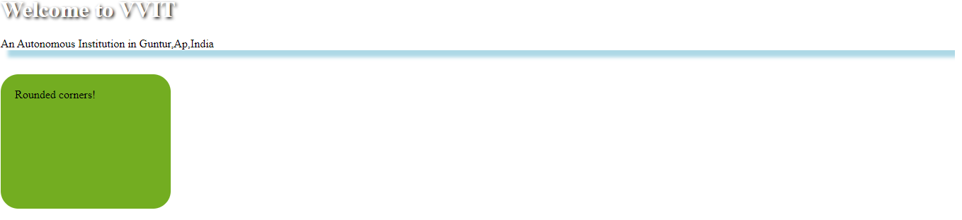
- Linear and Radial gradients

<html>
<head>
<style>
#grad1 {
height: 200px;
background-color: red; /* For browsers that do not support gradients */
background-image: linear-gradient(red, yellow);
}
#grad2 {
height: 150px;
width: 200px;
background-color: red; /* For browsers that do not support gradients */
background-image: radial-gradient(red 5%, yellow 15%, green 60%);
}
</style>
</head>
<body>

<p>This linear gradient starts red at the top, transitioning to yellow at the bottom:</p>

<div id="grad1"></div>
<h1>Radial Gradient - Differently Spaced Color Stops</h1>
<div id="grad2"></div>

</body>
</html>

Output:
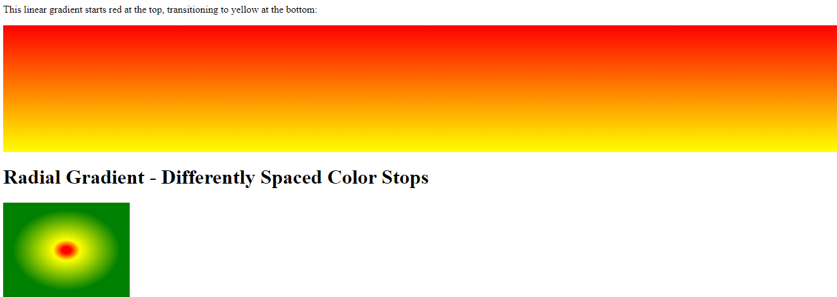

c). Animation
<html>
<head>
<style>
div {
width: 100px;
height: 100px;
background: red;
position: relative;
animation: mymove 5s infinite;
}

@keyframes mymove {
from {left: 0px;}
to {left: 200px;}
}
</style>
</head>
<body>

<h1>The animation Property</h1>

<p>Move an element from 0px to 200px left. The animation lasts for 5 seconds. It then starts over again, and go on forever (infinite).</p>
<div></div>

</body>
</html>

OUTPUT:
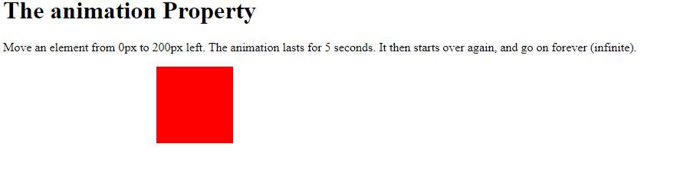
d). Transpositions and transforms
<html>
<head>
<style>
div {
width: 100px;
height: 100px;
background: red;
transition: width 2s, height 4s;
}

div:hover {
width: 300px;
height: 300px;
}
div.a {
width: 150px;
height: 80px;
background-color: yellow;
-ms-transform: rotate(20deg); /* IE 9 */
transform: rotate(20deg);
}
</style>
</head>
<body>

<h1>The transition Property</h1>

<p>Hover over the div element below, to see the transition effect:</p>

<div></div>
<h1>The transform Property</h1>

<h2>transform: rotate(20deg):</h2>
<div class="a">Hello World!</div>
<br>

</body>
</html>
OUTPUT:
